PLACEMENT REPORTS:

LOOKERSTUDIO

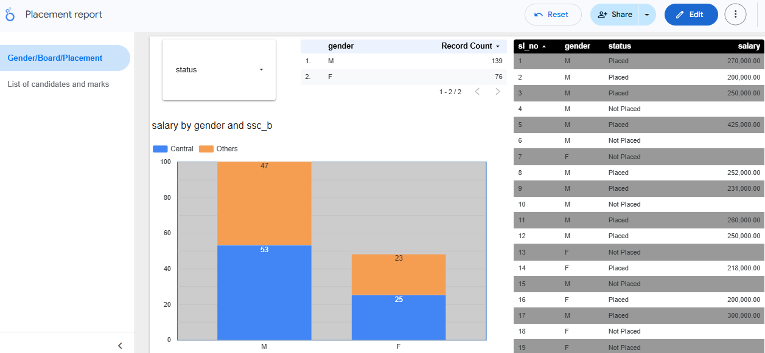

TABLEAU

POWER BI

